

ST6002CEM-Mobile Application Development

Project proposal

on

Job Mate

Submitted by: Ayush Shrestha

Coventry ID: 12979916

Batch: 32 A

Module Leader: Kiran Rana

Table of Contents

Introduction To Job Mate: A platform connecting Jobs seekers and employers 4

Justification of Job Mate 5

Description of the Project 6

Features 6

Aims and Objective 7

MVVM design pattern 8

Model 8

View 8

ViewModel 8

Configuration Management 9

Prototyping 10

Conclusion 20

References 21

Table of Figure

**Figure 1** GitHub Repository 9

**Figure 2** Prototype of Home Screen (Employer Side) 10

**Figure 3** Prototype of Job Post Builder Screen (Employer Side) 11

**Figure 4** Prototype of Hiring Progress Screen (Employer Side) 12

**Figure 5** Prototype of Hiring Progress Screen with status selector (Employer Side) 13

**Figure 6** Prototype of Home Screen (Applicant Side) 14

**Figure 7** Prototype of resume selection screen (Applicant Side) 15

**Figure 8** Prototype of Resume Builder Screen (Applicant Side) 16

**Figure 9** Prototype of Resume Display Screen (Applicant Side) 17

**Figure 10** Prototype of Splash Screen 17

**Figure 11** Prototype of Login Screen 18

**Figure 12** Prototype of Register Screen For Organization 19

# Introduction To Job Mate: A platform connecting Jobs seekers and employers

Job Mate, a mobile-based application, is created with the goal to bridge the gap between those looking for Jobs and those looking to hire the suitable people to fulfill a Job. This application will serve as a dual interface where employers can post jobs, manage candidate statuses, and oversee recruitment workflows, while job seekers can explore job opportunities, create, and submit resumes in PDF format, and apply for open job positions. Job Mate is designed with the end users in mind, carefully understanding their needs, providing a minimal yet necessary sets of features.

# Justification of Job Mate

**Job Mate’s Background**

The inspiration for the Job Mate comes from the growing need for a more dynamic and user-oriented job-hiring and job-finding solution. While the current platform that are similar in nature do exist, they are very complex to use and often are bloated with features that might not be needed for an average job seeker and employer. Employers face challenges in tracking applications, managing candidate statuses, and streamlining communication, while job seekers struggle with limited resume customization options. Recognizing these inefficiencies, Job Mate is designed to offer a seamless, and easy-to-use platform that facilitates all the major stages of the hiring process. This application aims to empower employers with better recruitment management capabilities and provide job seekers with robust tools for finding and securing jobs, ultimately enhancing the overall efficiency of the job market.

**Problem statement**

Traditional methods of job hiring and application management often present significant challenges for both employers and job seekers. Employers often struggle with efficient job posting, application tracking, and candidate management, leading to time-consuming and cumbersome processes. They also struggle to organize and streamline applicant data, resulting in delays and inefficiencies in the hiring process (Bika, 2023) . Meanwhile, job seekers encounter difficulties in finding relevant job opportunities, customizing their resumes, and receiving timely feedback on their applications. Furthermore, there is a lack of integrated e-commerce functionalities for employers to advertise job postings effectively. These limitations highlight the critical need for a user-friendly and comprehensive solution like Job Mate to address the inefficiencies and challenges faced by both employers and job seekers in the job-hiring process.

# Description of the Project

## Features

Job Mate will have the following features integrated in it:

1. **Job Posting Interface:** Streamlined tools for employers to create, edit, and manage job listings efficiently.
2. **Job Viewing interface:** Job seekers can view all the current Job listings, along with more details about the Job (for example: work type, who is hiring etc.)
3. **Hiring pipeline tracking:** A system to monitor the candidate statuses (e.g., interviewed, shortlisted, hired) through the recruitment process.
4. **Resume Builder and PDF Export:** Allows job seekers to create and export professional resumes directly within the app.
5. **Real-Time Notifications:** Instant updates for both employers and job seekers on application statuses and new job postings.
6. **User Profiles and Account Management:** Customizable profiles that store essential information of job seekers and employers.

# Aims and Objective

Job Mate aims to streamline the recruitment process by connecting employers and job seekers through a comprehensive, efficient mobile application. It facilitates efficient applicant tracking, finding the right jobs and talents, and creating resume with ease for the job seekers.

Following are the objective:

1. Explore the integration of Flutter and MongoDB to build a responsive and scalable mobile application framework.
2. Develop a comprehensive understanding of real-time notification systems within Flutter to ensure timely updates for job postings and applications.
3. Understand and apply MVVM (Model-View-ViewModel) design pattern in mobile app development.
4. Organize and manage project milestones to meet development timelines effectively.
5. Create a user-friendly job hiring platform that utilizes MongoDB for data storage, optimizing the recruitment process for both job seekers and employers.

# MVVM design pattern

The Model-view-viewmodel architectural pattern will be used to develop Job Mate.

## Model

Also known as the data layer, it manages data related to job postings, applications, and user profiles, ensuring data integrity and implementing business logic. It handles operations like data retrieval and storage in MongoDB.

## View

Also known as the presentation layer, it consists of the user interface where both job seekers and employers interact with features such as job listings, application forms, and profile settings. The View updates in response to changes in the ViewModel and captures user inputs.

## ViewModel

It handles the presentation logic and serves as the link between the Model and the View, handling data processing for display, such as organizing job listings and managing user sessions. It ensures that updates in the Model reflect in the View through data binding**.**

Having a well-organized three-tier architectural model like MVVM not only ensures our application is scalable, easily modifiable and easily maintainable but it also enhances the code readability and understandability for humans (Ramotion, 2023).

# Configuration Management

Here is the link to my GitHub for Job Mate: <https://github.com/ST60002CEM/batch32a-AayushShrestha007.git>

Here is a screenshot from my GitHub repo which shows the starting of the work.

**Figure 1**  
GitHub Repository

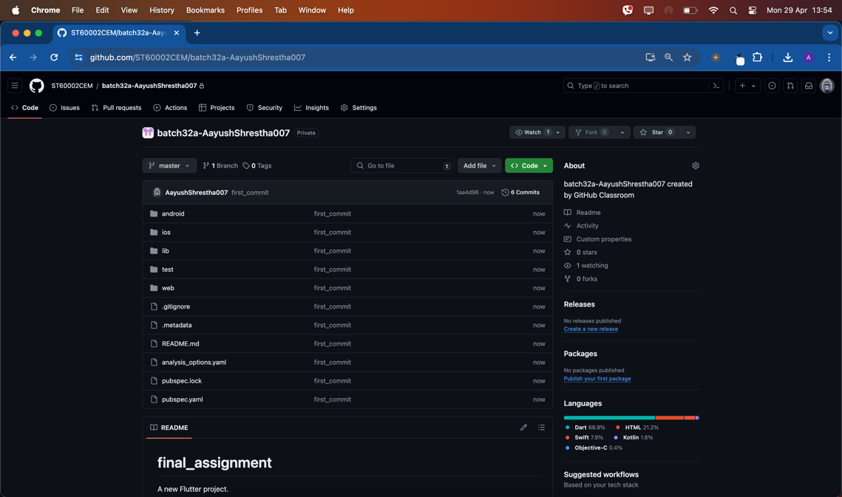

# Prototyping

To develop Job Mate, the first step is to create a Prototype. A prototype is a mockup of what the finished product will look like. Developing a Prototype first helped tremendously in setting the vision for the UI of Job Mate and gave a clearer perspective at the features that will be included (Douglas, 2023).

**Figure 2**  
Prototype of Home Screen (Employer Side)

**Figure 3**  
Prototype of Job Post Builder Screen (Employer Side)

**Figure 4**  
Prototype of Hiring Progress Screen (Employer Side)

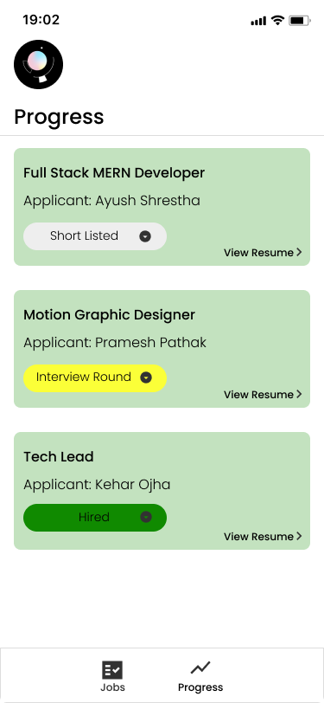

**Figure 5**  
Prototype of Hiring Progress Screen with status selector (Employer Side)

**Figure 6**  
Prototype of Home Screen (Applicant Side)

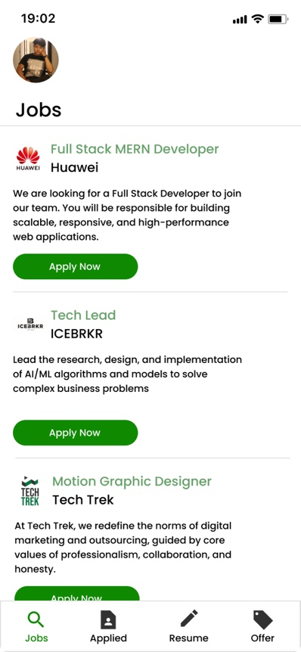

**Figure 7**  
Prototype of resume selection screen (Applicant Side)

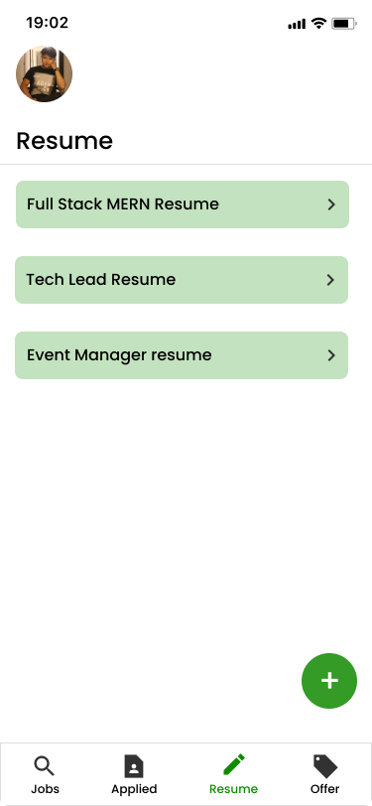

**Figure 8**  
Prototype of Resume Builder Screen (Applicant Side)

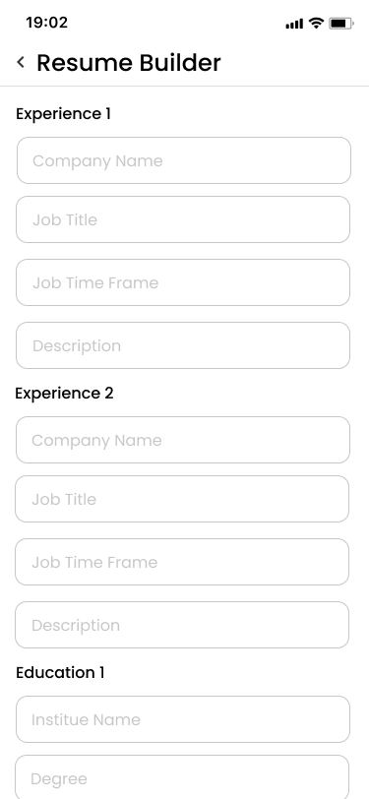

**Figure 9**  
Prototype of Resume Display Screen (Applicant Side)

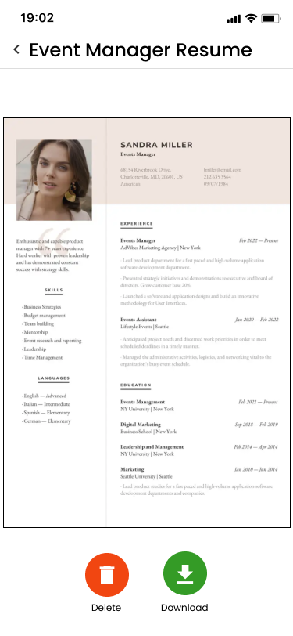

**Figure 10**  
Prototype of Splash Screen

**Figure 11**Prototype of Login Screen

**Figure 12**  
Prototype of Register Screen For Organization

# Conclusion

In conclusion, Job Mate is a forward-thinking mobile application designed to optimize the job recruitment process for both employers and job seekers. It effectively addresses common challenges in job hiring, such as application tracking and resume management, by leveraging a suite of features including an intuitive job posting interface, real-time notifications, resume builder etc. The adoption of the MVVM design pattern enhances the app's structure and usability, ensuring a smooth user experience. As a comprehensive tool in the field of job recruitment, Job Mate stands out by enhancing efficiency, being easy-to-use and facilitating better communication between job seekers and employers.

# References

*Bika, N. (2023, September 26). The most common recruiting challenges and how to overcome them. Recruiting Resources: How to Recruit and Hire Better. https://resources.workable.com/stories-and-insights/common-recruiting-challenges*

Ramotion. (2023, May 1). *Understanding MVVM: Model-View-ViewModel Architecture explained*. Web Design, UI/UX, Branding, and App Development Blog. https://www.ramotion.com/blog/what-is-mvvm/#:~:text=MVVM%20is%20useful%20because%20it,along%20with%20the%20business%20logic.

*Douglas, C. (2023, December 18). Benefits of prototyping - visily. Visily. https://www.visily.ai/blog/benefits-of-prototyping/*